Asbestos Sampling
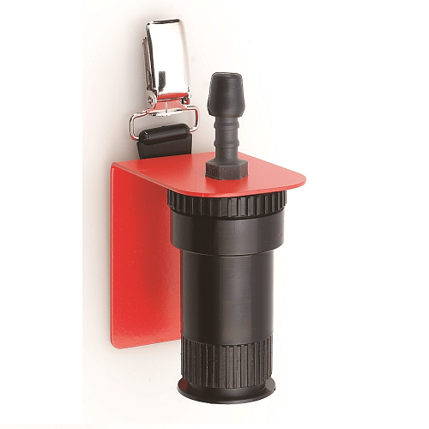
Any building constructed before the year 2000 could contain asbestos. When asbestos is disturbed, the fibres can be inhaled into the lungs and can cause asbestosis, lung cancer and a particularly aggressive cancer called Mesothelioma. These diseases cause up to 4,000 deaths a year in the UK alone and is the greatest cause of work-related deaths in the UK.
Asbestos can be found in:
- asbestos cement products, such as roof tiles and panelling
- textured coatings
- floor tiles, textiles (e.g. old fire blankets) and composites
- sprayed coatings on ceilings, walls and beams/columns
- asbestos insulating board
- lagging around boilers and pipework
- loose asbestos in ceiling or floor cavity
The use of static asbestos sampling or monitoring equipment is necessary for asbestos measurement when going through the asbestos removing process, and when accessing a site for reoccupation. In this situation the Asbestos sampling heads are used with the Flite4 sample pump, fitted with the sampling mast (as shown).
The sampling heads use 25 mm gridded filters.
We recommend preloaded BestChek cassettes for asbestos sampling.
SKC can also provide an Acetone Vapouriser, which is used to clear the filter (render the filter transparent) to enable the fibres to be more easily seen for analysis.

Flite4
Portable, versatile and fully programmable for high volume air sampling, SKC's Flite4 air sample pump provides high performance sampling for dusts, aerosols, fibres, and microbes. The Flite4 is ideal for static asbestos sampling and long-term background monitoring.
- Portable and versatile pump for high volume air sampling
- Ideal for asbestos monitoring
- Wide flow range
- Fully programmable run times
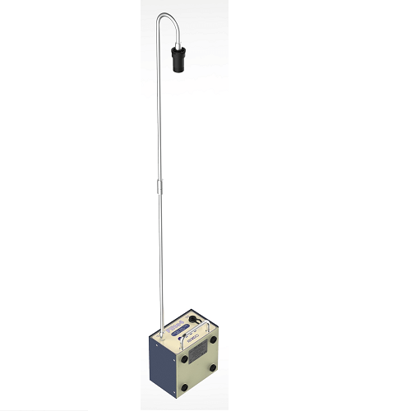
- Backlit display for use in dim/dark conditions
- Robust steel casing
- Small size - only 11 x 20 x 16 cm
- Operates from battery or AC
- High capacity (7Ah) battery model for longer run times - over 12 hours at 8 L/min
Applications
- Area and environmental monitoring
- BioSampling
- Indoor air studies
- Asbestos monitoring
- Long-term background monitoring
- Stack sampling
- European Vacuum Test (EVT) for ductwork, previously Preferred Vacuum Test (PVT), per BS EN 15780:2011 or BESA TR19
