Face Level Sampling – specifically designed for welding fumes
In February 2019 the HSE issued a safety alert on welding fume.
"New evidence shows exposure to mild steel welding fume can cause cancer. Employers should use suitable controls for all welding work. The Control of Substances Hazardous to Health direct advice for welding to help make sure exposure to any welding fume released is adequately controlled has been published, along with HSE’s web pages on how to manage exposure to welding fume"
From the HSE (29th June 2021): Breathing in welding fume and metalworking fluids can cause serious lung diseases.
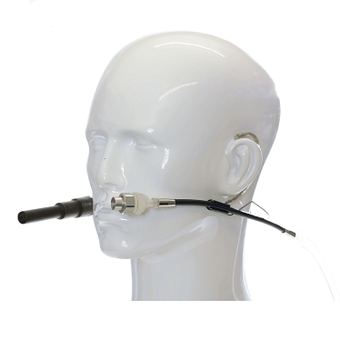
The SKC Face Level Sampling Headset is a personal air sampling media holder, featuring dual flexible sampling arms for parallel simultaneous samples and allows measurements inside personal protective equipment (PPE) such as masks and helmets, and is particularly suitable for sampling for hazardous metals in welding fume (such as manganese, nickel, chrome, etc) in welding applications.

- Lightweight and comfortable
- Fits inside welding masks and helmets
- Samples the inhalable fraction
- Meets BS EN ISO 10882-1:2011 - Health Safety in Welding and Allied Processes: Sampling of Airborne Particles
- Dual flexible arms for simultaneous sampling
- With the appropriate accessories the headset can be used with the following:
  - Mini Sampler for particulates
  - 6 x 70mm sorbent tubes for vapours*
* Contact SKC Limited for more information

The Face Level Sampling Headset was developed in a research project partly funded by the Swedish Work Environment Authority and carried out at Stockholm University, Sweden.

