Gastec Detection Tubes
SKC offer a broad range of gas detection tubes from Gastec. Their tubes are of the highest quality utilising colorimetric technology for accurately analysing a wide variety of gases, vapours and ground substances. Short-term Gastec gas detector tubes allow users to perform field screening, spot sampling and tests in industrial environments to detect hazardous and toxic gases, and chemical vapours - some suggested applications.
Gastec Injection Type Tubes
Gastec Compressed Breathing Air System
Gastec Smoke Tube Kit
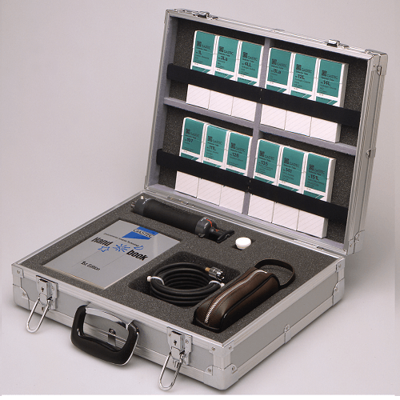
Gastec Colour Detector Tubes
Gastec Sample Pumps and Accessories
Gastec Dosimeter Tubes
Gastec Polytec Tubes
Gastec Pyrotec Tubes
Gastec Toxic Gas Detection System
Gastec Soluble Ion Tubes
Gastec Airtec Tubes

Gastec Toxic Gas Detection System

