Particulate Monitors
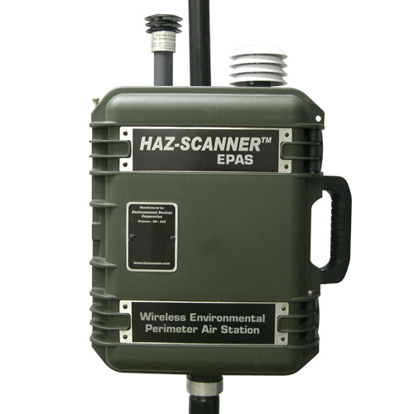
Particulates, or more specifically Particulate Matter (PM), are a mix of solid particles and liquid droplets suspended in air. If not properly managed particulates can be a health hazard to those exposed to them over a significant length of time. Particulates can take many forms including dry bulk foodstuffs, aggregates, aerosols, wood fibres and silica dust. SKC offers a wide range of direct reading instruments and dust monitors for monitoring particulates for personal exposure, workplace exposure and environmental monitoring, from the handheld respiratory monitor to the sophisticated ambient monitor for 24-hour sampling.
- HAZ-Dust IV
- HAZ-DUST 7204
- Split2
- HAZ-DUST 1
- EPAM 5000
- AIR-AIDE
- HAZ-SCANNER EPAS
- HAZ-DUST DPM-7204
- HAZ-DUST SM-7204
- HAZ-DUST HD-1620

