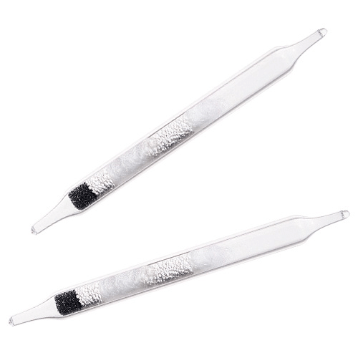
Sorbent Tubes
The sorbent in sorbent tubes is one of the types of sampling media used in air sampling, onto/into which the contaminant is collected. SKC produced the first commercial sorbent tube for NIOSH in 1973. Since then, SKC has remained on the leading edge of sorbent tube sampling by maintaining consistently high sorbent quality, expanding tube availability, and advancing sorbent technology.
Health and safety professionals around the globe at national and local levels choose SKC sorbent tubes for:
- Quality and reliability for compliance sampling
- Reproducible recoveries and low standard deviation
- Large lots with consistent results
- A complete line of tubes for occupational and environmental methods
- Fast delivery
- Responsive customer service and free technical support.
To select a tube for a specific compound refer to the SKC Sampling Guides or use our SKC online Hazard Database. We also have a useful leaflet on How to Use Sorbent Tubes.
Alternatively, see the tubes listed by sorbent type:
- Silica Gel
- Anasorb
- Charcoal
- Tenax
- XAD
- Chromosorb
- Polyurethane Foam
- Porapak
- Thermal Desorption
- Diffusive TD Tubes for VOCs
- Specific Sorbent Tubes
- Customised Sorbent Tubes
- OSHA Versatile Sample (OVS) Tubes
- Gas and Vapour Sampling

