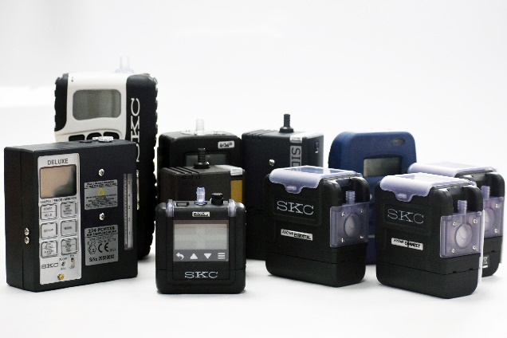
Air Sampling Pumps and Kits
SKC offers a wide range of pumps for all your air sampling and workplace air monitoring needs. Whether you are sampling for dusts/particulates, vapours/gases, bioaerosols or environmental, high or low flow rates, and whatever your environment we have a sample pump suitable for you. See our Sample Pump Selection Guide for more advice. Below is a selection of our pumps please see website for information on our complete range.
Sidekick Dust & Vapours
- Simple to use - ATEX and UKEX certified models
- Flow Range: 5 to 3000ml/min
AirChek 3000 Dust & Vapours
- ATEX, UKEX & IECEx Certified Ex/M1/EPL Ma Mine Certified
- Programmable
- Flow Range: 5 to 3250ml/min
AirChek Essential and Essential+ Dust & Vapours
- Touch Screen - Up to 40 hours run time
- Flow Range: 5 to 5000ml/min
AirChek Touch Dust & Vapours AirChek Connect Dust & Vapours
- Touch screens - Programmable
- Flow range: 5 to 5000ml/min
Universal Pump Dust & Vapours
- Built-in flow indicator
- ATEX & UKEX certified models
- Exhaust port for bag sampling -Flow range: 5 to 4000ml/min
Pocket Pump Touch Vapours
- Touch screen
- ATEX/UL approved -Flow range: 20 to 500ml/min
Leland Legacy Environmental. Bioaerosol.
- Ambient monitoring for dusts, bioaerosols or pesticides
- Up to 24 hour run time -Flow range: 5000 to 15000ml/min
Biolite+ Bioaerosol
- Specifically designed for sampling biological hazards
- Flow range: 0 to 62L/min

