Calibration
In the case of air sampling calibration is the setting of the air flow through the sample medium to the recommended level for the method being used. The flow should be checked before and after each sample. SKC offers a range of calibration equipment, and the choice of which calibrator depends on:
- Available budget
- Accuracy required by the method
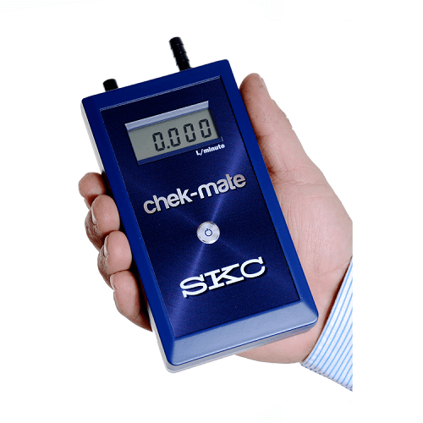
- Ease of use
- Fit for purpose
chek-mate Flowmeter
The SKC chek-mate Flowmeter is our easy-to-use differential pressure flowmeter for calibrating air flow sample pumps at flow ranges between
0.50-5.0 L/min, 20-500 ml/min and 5.0-30.0 L/min. The chek-mate meets the accuracy requirements of MDHS 14/4, and other HSE sampling methods.

- No moving parts
- Can be used in any orientation
- Built-in temperature and atmospheric pressure compensation
- Short stabilisation time
- Accuracy to 1% over the vast majority of the measuring range
- Auto-shutoff to conserve battery
- Compact, portable and lightweight
- Available in medium flow, low flow and high flow models:
  - 0.5 to 5.0 L/min
  - 20 to 500 ml/min
  - 5.0 to 30.0 L/min
- CalChek automatic flow calibration with specific SKC sample pumps (375-0550 and 375-50300 models only)
You can also choose from:
Rotameters
Bubble Film Flowmeters

