Passive Samplers
SKC passive (diffusive) samplers or "badges" are a range of small samplers that collect vapours and gases without the use of a pump. Individual chemicals simply diffuse from the atmosphere into the sampler at a fixed rate. Simple to use and convenient.
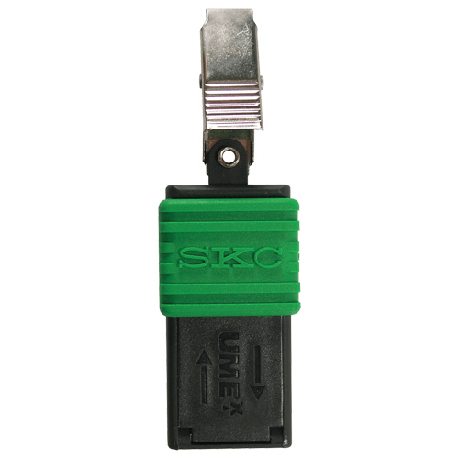
- Organic Vapour Passive Sampler
- ULTRA Passive Sampler
- UME^{x} 100 Formaldehyde Passive Sampler
- UME^{x} 200 SO₂/NO₂ Passive Sampler
- UME^{x} 300 Ammonia Passive Sampler
- UME^{x} 400 Aliphatic Amines Passive Sampler
- Ethylene Oxide Passive Sampler
- Hydrogen Cyanide Passive Sampler
- Elemental Mercury Passive Sampler
- Gastec Dosi-Tubes
- Ozone Test Strips
- Passive TD Tubes

UME^{x} 100 Formaldehyde Passive Sampler

