[**HAV-Sentry**](https://www.skcltd.com/vibration-monitoring.html) **Hand-Arm Vibration**

The HAV-Sentry system has been developed to provide real-time alerts based on personalised measurement of real-time hand-arm vibration exposure, preventing overexposure and driving the formation of robust control measures.

* Vibration exposures are measured not estimated
* Lightweight, breathable and comfortable liner - can be used underneath protection gloves if required
* Personalised and non-intrusive monitoring - no tool tags or wires
* Accelerometer and force sensor for a more comprehensive risk assessment
* IP64 protection - dust-proof and water-resistant
* Unique incremental live alerts based on real-time data
* Complies with BS ISO 5349 and BS ISO 8041
* Secure cloud storage of data

[**Noise Monitoring**](https://www.skcltd.com/noise-monitoring.html)

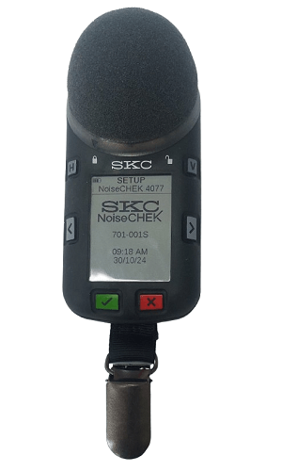The noise levels in the UK are governed by The Control of Noise at Work Regulations 2005. Only by checking noise levels can you ensure the levels are within the set guidelines and that workers are protected from risk of hearing damage at their place of work. Over 1 million employees in Great Britain are exposed to levels of noise that puts their hearing at risk. Of these upwards of 17,000 people suffer deafness, ringing in the ears or other ear conditions caused by excessive noise at work.

SKC can provide the following equipment for all your Noise monitoring needs:

* [NoiseCHEK Dosimeter](https://www.skcltd.com/products2/noise-monitoring/noisechek-dosimeter.html)
* [SoundCHEK Essential Sound Level Meter](https://www.skcltd.com/products2/noise-monitoring/soundchek-essential.html)
* [SoundCHEK Connect Sound Level Meter](https://www.skcltd.com/products2/noise-monitoring/soundchek-connect.html)
* [AcoustiCHEK Acoustic Calibrator](https://www.skcltd.com/products2/noise-monitoring/acoustichek-acoustic-calibrator.html)